Homework # 9

Ruchi Panwar (rpanwar@kent.edu)

Advance Database

Fall 2015

Professor: Dr. Gregory S DeLozier

Dec 03, 2015

**Aggregation**

**Aggregation program in python :**

Insert the data to aggrgation_example database.

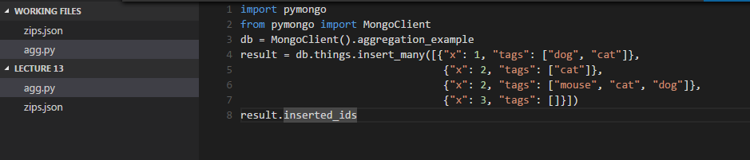

Data is been inserted to database aggrgation_example

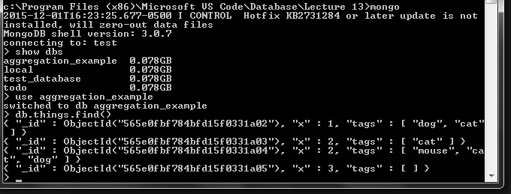

Add the aggregation code and execute the program

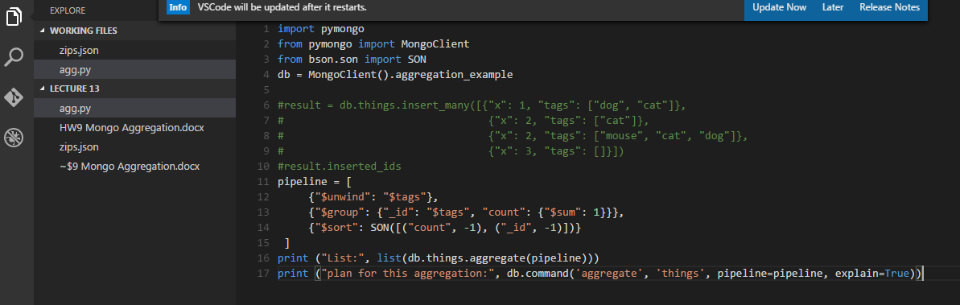

Output after aggregation and the plan for the aggregation:



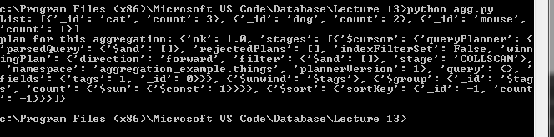

**Aggregation program using Zips.json file :**

Import the .json file using mongoimport

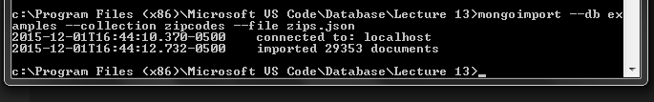

Once imported, execute the aggregation code : it will give the results for all the states that has population more than 10000000.

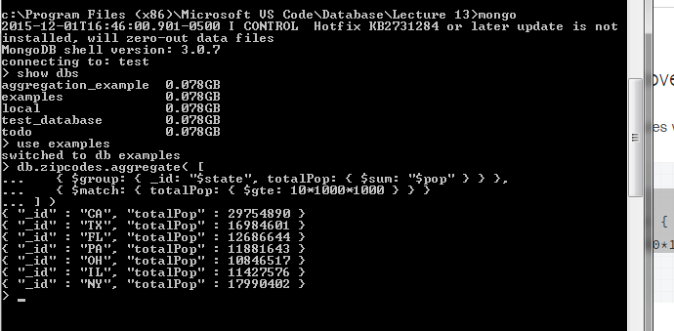

execute the multi stage aggregation code : it will provide the list of all the states with average population.

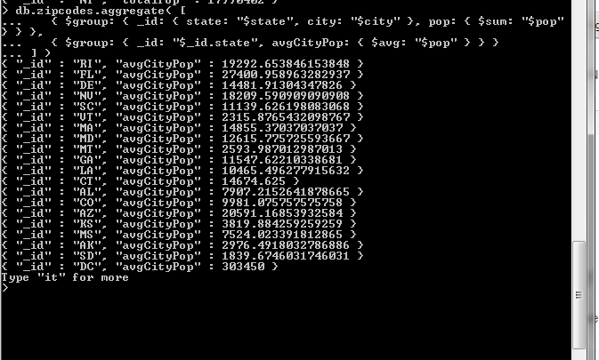

execute the multi complex aggregation code : it will provide the list of all the states with its biggest city, smallest city and their respective population.

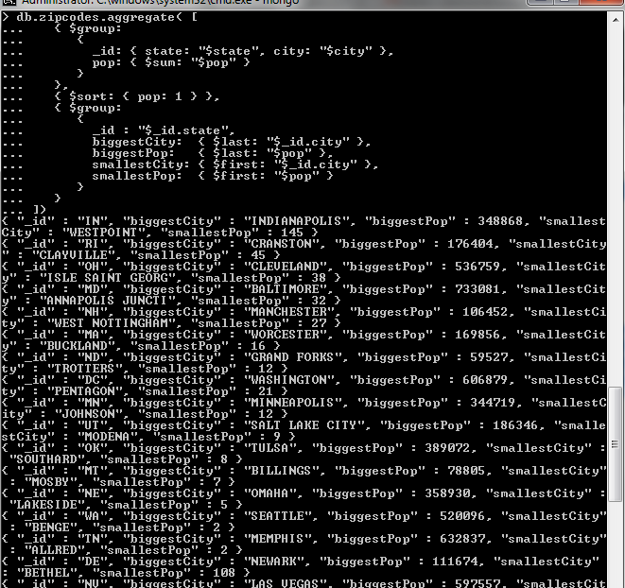

Add Projection stage and execute the code:

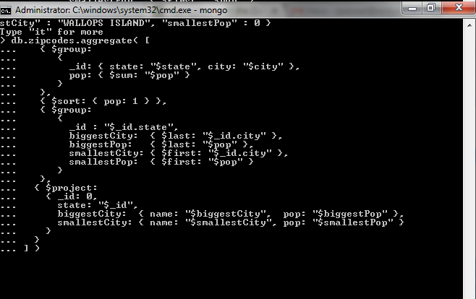

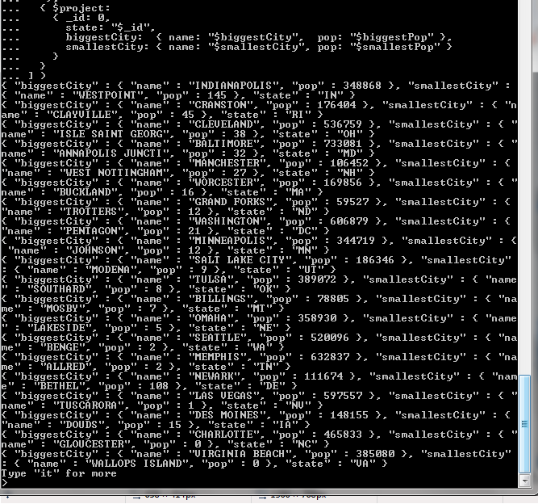

**Aggregation to Todo app**:

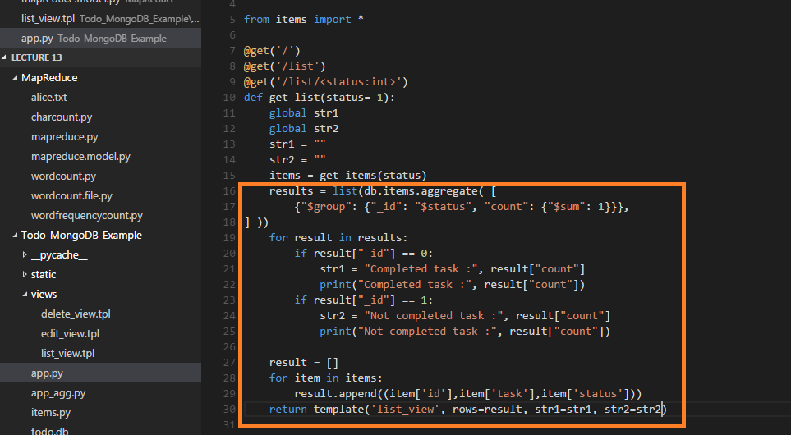

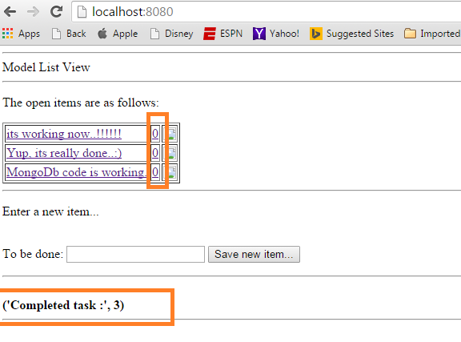

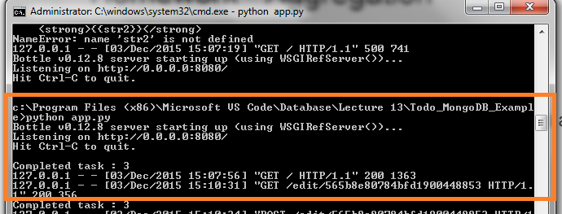

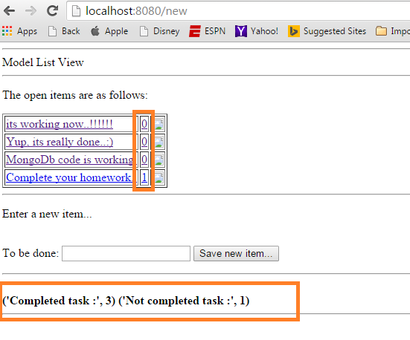

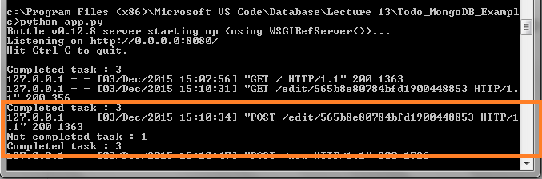

**MapReduce Example:**

**1.** program to count Words and its output

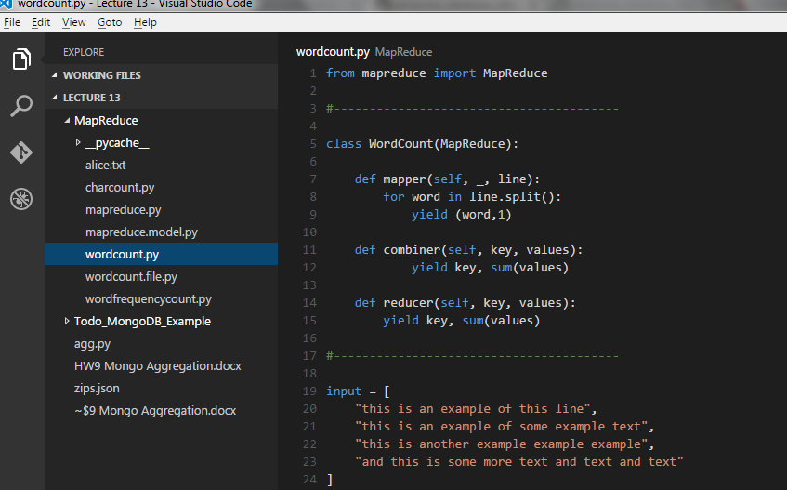

Output: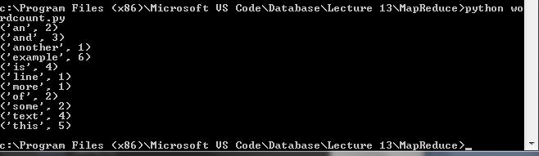

**2.** program to count frequency of the Words 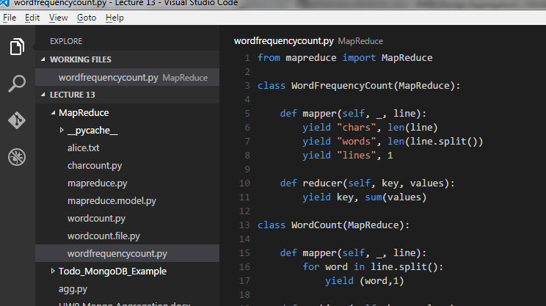

Output: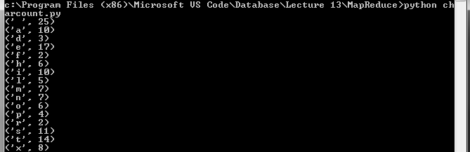

**3.** program to count the characters 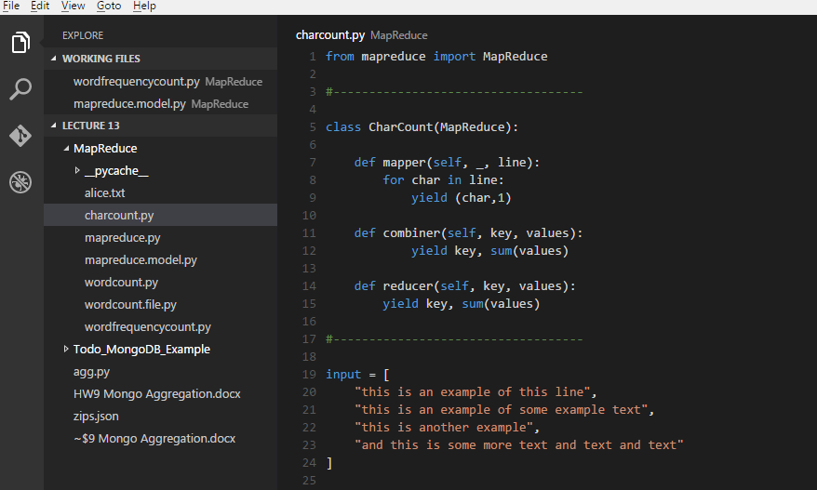

Output: